**PART B**

**Time:** 1.00 hour **Marks:** 15

**Consider the following Schema Diagram for understanding the structure and relationship among entities of a travel management system database and based on this diagram a database is created that will be shared with you. Now import the database and answer the following Queries.**

11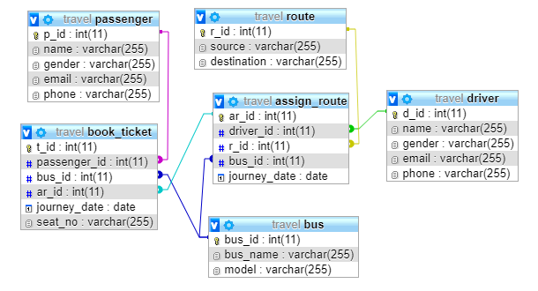

|  |  |
| --- | --- |
|  | [***Instruction*: Create a database named *travel* on MySql Database and execute the following query.]** |
| **1.** | Write query to find the drivers details who have visited on route 2. |
| **A:** | select name,gender,email,phone from driver inner join assign_route on driver.d_id=assign_route.driver_id inner join route on assign_route.r_id=route.r_id where assign_route.r_id=2; |
| **2.** | Display the passengers who have booked the ticket from Khulna to Barisal. |
| **A:** | [select](http://localhost/phpmyadmin/url.php?url=https://dev.mysql.com/doc/refman/5.5/en/select.html) name,gender,email,phone from passenger inner join book_ticket onpassenger.p_id=book_ticket.passenger_id inner join assign_route on book_ticket.ar_id=assign_route.ar_id innerjoin route on assign_route.r_id=route.r_id WHERE route.source='Khulna' [and](http://localhost/phpmyadmin/url.php?url=https://dev.mysql.com/doc/refman/5.5/en/logical-operators.html#operator_and) route.destination='Barisal' |
| **3.** | List the details of passengers who have traveled more than three times on the same route. |
| **A:** | select name,gender,email,phone from passenger inner join book_ticket on passenger.p_id=book_ticket.passenger_id inner join assign_route on book_ticket.ar_id=assign_route.ar_id inner join route on assign_route.r_id=route.r_id  group by route.r_id  having count(route.r_id)>3; |
| **4.** | Write a query to find the passenger details who will travel on 15-11-2019 by bus 3. |
| **A:** |  |
| **5.** | Find the list of female passengers. |
| **A:** | select * from passenger  where passenger.gender='female'; |
| **6.** | Find the details of the passenger who have booked the seat A4 on the bus no 1. |
| **A:** |  |
| **7.** | Create a view for the following problem:  Find the details of driver who have travelled most. |
| **A:** |  |
| **8.** | Write a query to change the constraint into unique of the attributes phone and email on the table passenger. |
| **A:** |  |
| **9.** | Write a query to change the driver phone operator into airtel those who are using banglalink. [hints: only the operator identifier code will be changed.] |
| **A:** | select replace(phone,'019','018')as newphone from driver; |
| **10.** | Write a query to add a column license_number before model in the table bus. |
| **A:** | alter table bus  add column license_number int(11) ; |

**Good Luck!!!**